Structuring Unstructured Data with LLMs: DSPy Practical Assignment
Name – Arghya Bandyopadhyay , College – Meghnad Saha institute Of Technology

Why This Matters

Unstructured data (text, PDFs, web content) makes up 80-90% of data, yet it’s unusable for analysis without costly manual processing. LLMs solve this by acting as "structured data compilers" – converting messy text into clean, queryable formats (entities, relations, graphs). This assignment tests your ability to:
- Bridge theory and practice (real-world data ≠ textbook examples)
- Handle LLM uncertainty (confidence loops, error resilience)
- Build production-ready pipelines (not just one-off scripts)
The provided DSPy codebase demonstrates exactly what modern data engineering teams need:
- Entity extraction → Turning text into typed objects (e.g., "pelletized frass" → Drug)
- Intelligent deduplication → Solving real-world noise (e.g., "PB IC", "pea-barley intercrop", "pea-barley intercrops" → 1 entity)
- Knowledge graph generation → Creating visual, queryable relationships (Mermaid diagrams)

Code Walkthrough (Key Concepts for Applicants)

Code Sample: https://colab.research.google.com/drive/1b-w8EBRn_bRCysFnnBNUXCqg05KR8VsX?usp=sharing

1. Entity Extraction (ExtractEntities Signature)

class EntityWithAttr(BaseModel):
entity: str = Field(description="the named entity")
attr_type: str = Field(description="semantic type (e.g. Drug, Disease)")

class ExtractEntities(dspy.Signature):
paragraph: str = dspy.InputField()
entities: List[EntityWithAttr] = dspy.OutputField()

- Why it’s clever: Uses Pydantic to force structured outputs from LLMs. No more regex parsing of free-text responses!
- Your takeaway: Always define exactly what the LLM should output. DSPy validates responses against your schema.

2. Deduplication with Confidence Loops

def deduplicate_with_lm(items, batch_size=10, target_confidence=0.9):
while True:
pred = dedup_predictor(items=batch)
if pred.confidence >= target_confidence: # Critical safety check!
return pred.deduplicated

- Why it’s clever: LLMs hallucinate. This loop self-corrects until confidence ≥ 90%.
- Your takeaway: Never trust a single LLM call. Always add validation loops for critical tasks.

3. Mermaid Graph Generation

def triples_to_mermaid(triples, entity_list):
# Only allows entities from our deduplicated list as nodes
entity_set = {e.strip().lower() for e in entity_list}
...
lines.append(f" {_clean(src)} -- {lbl} --> {_clean(dst)}")

- Why it’s clever: Prevents "garbage nodes" by strictly enforcing entity validity.
- Your takeaway: Output formats must be robust – real data breaks naive assumptions.
- Mermaid link

Your Assignment (Due in 72 Hours)

Task
Scrape 10 URLs (provided below), process their text using the DSPy pipeline, and deliver:
- 10 Mermaid diagrams (one per URL) visualizing key relationships.
- A structured CSV with columns: link, tag, tag_type.
- A Colab notebook showing your full implementation.

URLs to Scrape
- https://en.wikipedia.org/wiki/Sustainable_agriculture
- https://www.nature.com/articles/d41586-025-03353-5
- https://www.sciencedirect.com/science/article/pii/S1043661820315152
- https://www.ncbi.nlm.nih.gov/pmc/articles/PMC10457221/
- https://www.fao.org/3/y4671e/y4671e06.htm
- https://www.medscape.com/viewarticle/time-reconsider-tramadol-chronic-pain-2025a1000ria
- https://www.sciencedirect.com/science/article/pii/S0378378220307088
- https://www.frontiersin.org/news/2025/09/01/rectangle-telescope-finding-habitable-planets
- https://www.medscape.com/viewarticle/second-dose-boosts-shingles-protection-adults-aged-65-years-2025a1000ro7
- https://www.theguardian.com/global-development/2025/oct/13/astro-ambassadors-stargazers-himalayas-hanle-ladakh-india

Assignment Deliverables

1. Mermaid Diagrams (10 total)
- Save as mermaid_{i}.md (e.g., mermaid_1.md)
- Must include:
  - Valid Mermaid syntax (test in Mermaid Live Editor)
  - Only entities from your deduplicated list as nodes
  - Edge labels trimmed to 40 chars (as in example)

2. Structured CSV (tags.csv) (Double click on this table to get the full view)
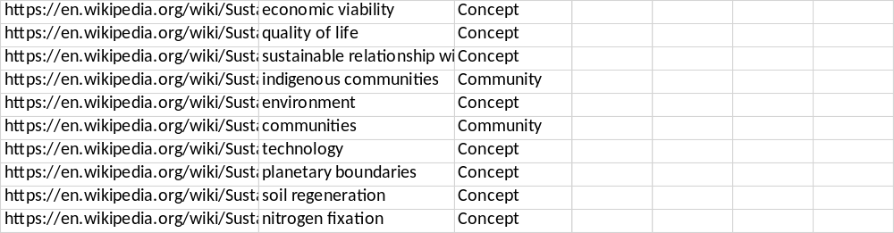
Rules:
- tag: Exact entity string (e.g., "pea-barley intercrop", not "intercrop")
- tag_type: Semantic category (e.g., Crop, Process, Measurement)
- No duplicates per URL (use your deduplication logic!)

3. Colab Notebook
- Must include:
  - https://colab.research.google.com/drive/1yFatz37O9OW3Dusso8E0YDVj-6P0GY69?usp=sharing
  - Output csv

How to get Free LLM API key to use with DSPY?
- Follow steps using your own account to get Free LLM api keys from here: https://scribehow.com/viewer/Sign_Up_for_Longcat_API_Platform__9sYiobPNS0OnXzyxKHu4zg?add_to_team_with_invite=True&sharer_domain=gmail.com&sharer_id=e0b8270f-e494-45b1-b41a-c6adf9f11845
- You might run into limits, so you can ask to increase your limits- https://scribehow.com/viewer/Request_More_LongCat_API_Quota__0kdRFlLmTdKCuIL67qz_rA?add_to_team_with_invite=True&sharer_domain=gmail.com&sharer_id=e0b8270f-e494-45b1-b41a-c6adf9f11845

